

Compensation and Pension Record Interchange (CAPRI)

Parkinson’s Disease

Disability Benefits Questionnaire (DBQ)

Workflow

November 2010

Department of Veterans Affairs
Office of Enterprise Development
Management & Financial Systems

Revision History

Date | Description (Patch # if applicable) | Author | Technical Writer
08/02/2010 | Document created for patch 154. | C. Gawronski | J. Headen
10/12/2010 | Changes to support Urinary problems for patch 159. | C. Gawronski | n/a
11/1/2010 | Changed wording in Introduction for patch 159. | C. Gawronski | n/a

Table of Contents

1 Introduction 1
1.1 Purpose 1
1.2 Overview 1
2 Parkinson’s Disease DBQ – History Tab 2
2.1 Name of patient/Veteran 2
2.2 Section 1. Diagnosis 2
2.3 Section 2. Dominant Hand 3
2.4 Section 3. Motor manifestations due to Parkinson’s or its treatment 4
2.5 Section 4. Mental manifestations due to Parkinson’s or its treatment 7
2.6 Section 5. Additional manifestations/complications due to Parkinson’s or its treatment 8
2.7 Section 6. Financial responsibility 11
2.8 Section 7. Functional impact 11
2.9 Section 8. Remarks 12
3 Parkinson’s Disease AMIE Worksheet 14

Table of Figures and Tables

Figure 1: Template Example: DBQ – Standard VA Note 1
Figure 2: Print Example: DBQ – Standard VA Note 1
Figure 3: Template Example: DBQ – Parkinson’s Disease – Name of patient/Veteran 2
Figure 4: Print Example: DBQ – Parkinson’s Disease – Name of patient/Veteran 2
Figure 5: Template Example: DBQ – Parkinson’s Disease – 1. Diagnosis 3
Figure 6: Print Example: DBQ – Parkinson’s Disease – 1. Diagnosis 3
Figure 7: Template Example: DBQ – Parkinson’s Disease – 2. Dominant hand 4
Figure 8: Print Example: DBQ – Parkinson’s Disease – 2. Dominant hand 4
Figure 9: Template Example:DBQ – Parkinson’s Disease – 3. Motor manifestations due to Parkinson’s or its treatment 6
Figure 10: Print Example: DBQ – Parkinson’s Disease – 3. Motor manifestations due to Parkinson’s or its treatment 7
Figure 11: Template Example: DBQ – Parkinson’s Disease – 4. Mental manifestations due to Parkinson’s or its treatment 8
Figure 12: Print Example:DBQ – Parkinson’s Disease – 4. Mental manifestations due to Parkinson’s or its treatment 8
Figure 13: Template Example: DBQ – Parkinson’s Disease – 5. Additional manifestations/complications due to Parkinson’s or its treatment 10
Figure 14: Print Example: DBQ – Parkinson’s Disease – 5. Additional manifestations/complications due to Parkinson’s or its treatment 10
Figure 15: Template Example: DBQ – Parkinson’s Disease – 6. Financial responsibility 11
Figure 16: Print Example: DBQ – Parkinson’s Disease – 6. Financial responsibility 11
Figure 17: Template Example: DBQ – Parkinson’s Disease – 7. Functional impact 12
Figure 18: Print Example: DBQ – Parkinson’s Disease – 7. Functional impact 12
Figure 19: Template Example: DBQ – Parkinson’s Disease – 8. Remarks 13
Figure 20: Print Example: DBQ – Parkinson’s Disease – 6. Remarks 13

Table 1: Rules: DBQ – Parkinson’s Disease – Name of patient/Veteran 2
Table 2: Rules: DBQ – Parkinson’s Disease – 1. Diagnosis 3
Table 3: Rules: DBQ – Parkinson’s Disease – 2. Dominant hand 4
Table 4: Rules: DBQ – Parkinson’s Disease – 3. Motor manifestations due to Parkinson’s or its treatment 4
Table 5: Rules: DBQ – Parkinson’s Disease – 4. Mental manifestations due to Parkinson’s or its treatment 8
Table 6: Rules: DBQ – Parkinson’s Disease – 5. Additional manifestations/complications due to Parkinson’s or its treatment 9
Table 7: Rules: DBQ – Parkinson’s Disease – 6. Financial responsibility 11
Table 8: Rules: DBQ – Parkinson’s Disease – 7. Functional impact 12
Table 9: Rules: DBQ – Parkinson’s Disease – 8. Remarks 13

Introduction

Purpose
This document provides a high level overview of the contents found on the PARKINSON’S DISEASE Disability Benefits Questionnaire (DBQ). The DBQ can be populated via an online template within the CAPRI C&P Worksheets tab and then printed OR it can be printed via AMIE (AUTOMATED MEDICAL INFORMATION EXCHANGE) and then manually populated. This document contains the edit rules for the template as well as examples of how the template will look online in CAPRI or printed from CAPRI. It also contains the layout for the AMIE worksheet to depict how it will look when printed from AMIE.

For more detailed information on standard template functionality not covered in this document, please refer to the C&P Worksheet Tab Functionalities section of the CAPRI GUI User Guide.

Overview
The PARKINSON’S DISEASE DBQ provides the ability to capture information related to Parkinson’s disease and its treatment.

Each DBQ template contains a standard footer containing a note stating that the “VA may request additional medical information, including additional examinations if necessary to complete VA’s review of Veteran’s application”. (see Figure 1 and 2).

Figure 1: Template Example: DBQ – Standard VA Note
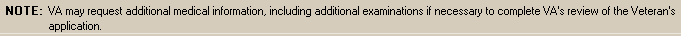

Figure 2: Print Example: DBQ – Standard VA Note

NOTE: VA may request additional medical information, including additional

examinations if necessary to complete VA's review of the Veteran's application.

A number of fields on the PARKINSON’S DISEASE template are mandatory and require a response (value) prior to the exam being marked as completed. Some questions may activate a Pop-up window displaying information as to each question that needs to be answered before the template can be completed.

Parkinson’s Disease DBQ – History Tab

Name of patient/Veteran
All questions in this section must be answered as described by the rules below. If all mandatory questions are not answered, the error message(s) will appear in a popup window displaying the error message depicted below.

Table 1: Rules: DBQ – Parkinson’s Disease – Name of patient/Veteran
Field/Question | Field Disposition | Valid Values | Format | Error Message
Disability Benefits Questionnaire | Disabled, Read-Only | N/A | N/A | N/A
Parkinson’s Disease | Disabled, Read-Only | N/A | N/A | N/A
Name of patient/Veteran | Enabled, Mandatory | N/A | Free Text | Please enter the name of the patient/Veteran.
Your patient is applying to the U. S. Department of Veterans Affairs (VA) for disability benefits. VA will consider the information you provide on this questionnaire as part of their evaluation in processing the Veteran’s claim. | Disabled, Read-Only | N/A | N/A | N/A

Figure 3: Template Example: DBQ – Parkinson’s Disease – Name of patient/Veteran
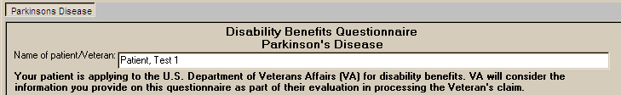

Figure 4: Print Example: DBQ – Parkinson’s Disease – Name of patient/Veteran

Disability Benefits Questionnaire

Parkinson's Disease

Name of patient/Veteran: Patient, Test 1

Your patient is applying to the U.S. Department of Veterans Affairs (VA) for
disability benefits. VA will consider the information you provide on this
questionnaire as part of their evaluation in processing the Veteran's claim.

Section 1. Diagnosis
The question “Does the patient/Veteran now have or has he/she ever been diagnosed with Parkinson’s disease?” must be answered before the template can be completed.

- If it is answered with Yes, all other questions requiring an answer as described by the rules in this document must be answered before the template can be completed.
- If it is answered with No, the template may be completed without answering any additional questions or the user may input answers to any of the optional questions as indicated by the rules described in this document.

Note: Some questions will activate secondary question(s) when answered. If a secondary question is answered and the primary question that triggered the secondary question is unanswered or if answered in a way where this information is no longer required, the previously entered data will be removed and the question may become disabled if it is no longer relevant.

All questions will be printed even if they have not been answered.

If all mandatory questions are not answered, the error message(s) will appear in a popup window as depicted below and must be answered before this template can be completed.

Table 2: Rules: DBQ – Parkinson’s Disease – 1. Diagnosis
Field/Question | Field Disposition | Valid Values | Format | Error Message
1.Diagnosis | Disabled, Read-Only | N/A | N/A | N/A
Does the Veteran now have or has he/she ever been diagnosed with Parkinson's disease? | Enabled, Mandatory, Choose one valid value | [Yes; No] | N/A | Please answer the question: Does the Veteran now have or has he/she ever been diagnosed with Parkinson's disease?
ICD code: | If Diagnosis = Yes; Enabled, Mandatory  Else; Enabled, Optional | N/A | Free Text | Please enter the ICD code.
Date of diagnosis | If Diagnosis = Yes; Enabled, Mandatory  Else; Enabled, Optional | N/A | Free Text | Please enter the date of diagnosis.

Figure 5: Template Example: DBQ – Parkinson’s Disease – 1. Diagnosis
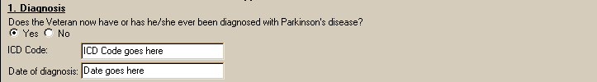

Figure 6: Print Example: DBQ – Parkinson’s Disease – 1. Diagnosis

1. Diagnosis

------------

Does the Veteran now have or has he/she ever been diagnosed of Parkinson's

Disease? [X] Yes [ ] No

ICD Code: ICD Code goes here

Date of diagnosis Date goes here

Section 2. Dominant Hand
All questions in this section may be answered as described by the rules below. If all mandatory questions are not answered, the error message(s) will appear in a popup window displaying the error message depicted below.

Table 3: Rules: DBQ – Parkinson’s Disease – 2. Dominant hand
Field/Question | Field Disposition | Valid Values | Format | Error Message
2.Dominant Hand | If Diagnosis = Yes; Enabled, Mandatory, Choose one valid value  Else; Enabled, Optional | [Right; Left; Ambidextrous] | N/A | Please indicate which hand is the dominant hand.

Figure 7: Template Example: DBQ – Parkinson’s Disease – 2. Dominant hand
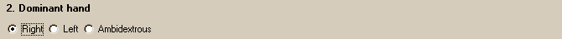

Figure 8: Print Example: DBQ – Parkinson’s Disease – 2. Dominant hand

2. Dominant hand

----------------

[X] Right [ ] Left [ ] Ambidextrous

Section 3. Motor manifestations due to Parkinson’s or its treatment

All questions in this section may be answered as described by the rules below. If all mandatory questions are not answered, the error message(s) will appear in a popup window displaying the error message depicted below.

Table 4: Rules: DBQ – Parkinson’s Disease – 3. Motor manifestations due to Parkinson’s or its treatment
Field/Question | Field Disposition | Valid Values | Format | Error Message
3. Motor manifestations due to Parkinson’s or its treatment (check all that apply) | Disabled, Read-Only | N/A | N/A | N/A
Stooped posture | If diagnosis = Yes; Enabled, Mandatory, Choose one valid value  Else; Enabled, Optional | [None;  Mild; Moderate; Severe] | N/A | Please indicate whether the Veteran has stooped posture due to Parkinson's disease or its treatment.
Balance impairment | If diagnosis = Yes; Enabled, Mandatory, Choose one valid value  Else; Enabled, Optional | [None;  Mild; Moderate;  Severe] | N/A | Please indicate whether the Veteran has balance impairment due to Parkinson's disease or its treatment.
Bradykinesia or slowed motion (difficulty initiating movement, “freezing,” short shuffling steps) | If diagnosis = Yes; Enabled, Mandatory, Choose one valid value  Else; Enabled, Optional | [None;  Mild; Moderate; Severe] | N/A | Please indicate whether the Veteran has bradykinesia or slowed motion due to Parkinson's disease or its treatment.
Loss of automatic movements (such as blinking, leading to fixed gaze; typical Parkinson’s facies) | If diagnosis = Yes; Enabled, Mandatory, Choose one valid value  Else; Enabled, Optional | [None;  Mild; Moderate; Severe] | N/A | Please indicate whether the Veteran has loss of automatic movements due to Parkinson's disease or its treatment.
Speech changes (monotone, slurring words, soft or rapid speech) | If diagnosis = Yes; Enabled, Mandatory, Choose one valid value  Else; Enabled, Optional | [None;  Mild; Moderate; Severe] | N/A | Please indicate whether the Veteran has speech changes due to Parkinson's disease or its treatment.
Tremor (characteristic hand shaking, “pill-rolling”) | If diagnosis = Yes; Enabled, Mandatory, Choose one valid value  Else; Enabled, Optional | [Yes; No] | N/A | Please indicate whether the Veteran has tremor due to Parkinson's disease or its treatment.
Extremities affected: Right Upper | If Tremor = Yes; Enabled, Mandatory, Choose one valid value  Else; Disabled | [Not affected; Mild; Moderate; Severe] | N/A | Please indicate whether the Veteran has right upper extremity tremor due to Parkinson's disease or its treatment.
Extremities affected: Left Upper | If Tremor = Yes; Enabled, Mandatory, Choose one valid value  Else; Disabled | [Not affected; Mild; Moderate; Severe] | N/A | Please indicate whether the Veteran has left upper extremity tremor due to Parkinson's disease or its treatment.
Extremities affected: Right Lower | If Tremor = Yes; Enabled, Mandatory, Choose one valid value  Else; Disabled | [Not affected; Mild; Moderate; Severe] | N/A | Please indicate whether the Veteran has right lower extremity tremor due to Parkinson's disease or its treatment.
Extremities affected: Left Lower | If Tremor = Yes; Enabled, Mandatory, Choose one valid value  Else; Disabled | [Not affected; Mild; Moderate; Severe] | N/A | Please indicate whether the Veteran has left lower extremity tremor due to Parkinson's disease or its treatment.
Muscle rigidity and stiffness | If diagnosis = Yes; Enabled, Mandatory, Choose one valid value  Else; Enabled, Optional | [Yes; No] | N/A | Please indicate whether the Veteran has muscle rigidity and stiffness due to Parkinson's disease or its treatment.
Extremities affected: Right Upper | If Muscle rigidity and stiffness  = Yes; Enabled, Mandatory, Choose one valid value  Else; Disabled | [Not affected; Mild; Moderate; Severe] | N/A | Please indicate whether the Veteran has right upper extremity muscle rigidity and stiffness due to Parkinson's disease or its treatment.
Extremities affected: Left Upper | If Muscle rigidity and stiffness  = Yes; Enabled, Mandatory, Choose one valid value  Else; Disabled | [Not affected; Mild; Moderate; Severe] | N/A | Please indicate whether the Veteran has left upper extremity muscle rigidity and stiffness due to Parkinson's disease or its treatment.
Extremities affected: Right Lower | If Muscle rigidity and stiffness  = Yes; Enabled, Mandatory, Choose one valid value  Else; Disabled | [Not affected; Mild; Moderate; Severe] | N/A | Please indicate whether the Veteran has right lower extremity muscle rigidity and stiffness due to Parkinson's disease or its treatment.
Extremities affected: Left Lower | If Muscle rigidity and stiffness  = Yes; Enabled, Mandatory, Choose one valid value  Else; Disabled | [Not affected; Mild; Moderate; Severe] | N/A | Please indicate whether the Veteran has left lower extremity muscle rigidity and stiffness due to Parkinson's disease or its treatment.

Figure 9: Template Example:DBQ – Parkinson’s Disease – 3. Motor manifestations due to Parkinson’s or its treatment
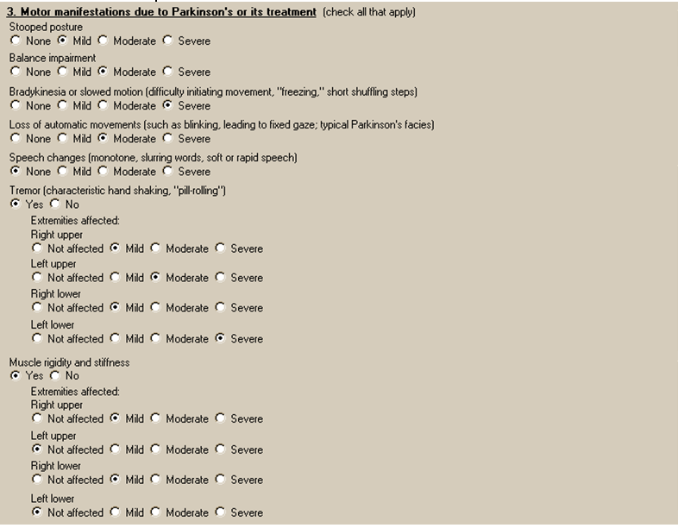

Figure 10: Print Example: DBQ – Parkinson’s Disease – 3. Motor manifestations due to Parkinson’s or its treatment

3. Motor manifestations due to Parkinson's or its treatment (check all that apply)

-----------------------------------------------------------

Stooped posture

[ ] None [X] Mild [ ] Moderate [ ] Severe

Balance impairment

[ ] None [ ] Mild [X] Moderate [ ] Severe

Bradykinesia or slowed motion

(difficulty initiating movement, "freezing", short shuffling steps)

[ ] None [ ] Mild [ ] Moderate [X] Severe

Loss of automatic movements

(such as blinking, leading to fixed gaze; typical Parkinson's facies)

[ ] None [ ] Mild [X] Moderate [ ] Severe

Speech changes (monotone, slurring words, soft or rapid speech)

[X] None [ ] Mild [ ] Moderate [ ] Severe

Tremor (characteristic hand shaking, "pill-rolling") [X] Yes [ ] No

Extremities affected:

[X] Right upper

[ ] Not affected [X] Mild [ ] Moderate [ ] Severe

[X] Left upper

[ ] Not affected [ ] Mild [X] Moderate [ ] Severe

[X] Right lower

[ ] Not affected [X] Mild [ ] Moderate [ ] Severe

[X] Left lower

[ ] Not affected [ ] Mild [ ] Moderate [X] Severe

Muscle rigidity and stiffness [X] Yes [ ] No

Extremities affected:

[X] Right upper

[ ] Not affected [X] Mild [ ] Moderate [ ] Severe

[X] Left upper

[X] Not affected [ ] Mild [ ] Moderate [ ] Severe

[X] Right lower

[ ] Not affected [X] Mild [ ] Moderate [ ] Severe

[X] Left lower

[X] Not affected [ ] Mild [ ] Moderate [ ] Severe

Section 4. Mental manifestations due to Parkinson’s or its treatment
All questions in this section may be answered as described by the rules below. If all mandatory questions are not answered, the error message(s) will appear in a popup window displaying the error message depicted below.

Table 5: Rules: DBQ – Parkinson’s Disease – 4. Mental manifestations due to Parkinson’s or its treatment
Field/Question | Field Disposition | Valid Values | Format | Error Message
4. Mental manifestations due to Parkinson’s or its treatment | Disabled, Read-Only | N/A | N/A | N/A
Depression | If diagnosis = Yes; Enabled, Mandatory, Choose one valid value  Else; Enabled, Optional | [None; Mild; Moderate; Severe] | N/A | Please indicate whether the Veteran has depression due to Parkinson's disease or its treatment.
Cognitive impairment or dementia | If diagnosis = Yes; Enabled, Mandatory, Choose one valid value  Else; Enabled, Optional | [None; Mild; Moderate; Severe] | N/A | Please indicate whether the Veteran has cognitive impairment or dementia due to Parkinson's disease or its treatment.

Figure 11: Template Example: DBQ – Parkinson’s Disease – 4. Mental manifestations due to Parkinson’s or its treatment
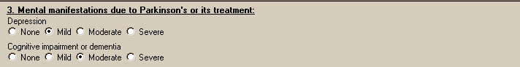

Figure 12: Print Example:DBQ – Parkinson’s Disease – 4. Mental manifestations due to Parkinson’s or its treatment

4. Mental manifestations due to Parkinson's or its treatment

------------------------------------------------------------

Depression

[ ] None [X] Mild [ ] Moderate [ ] Severe

Cognitive impairment or dementia

[X] None [ ] Mild [ ] Moderate [ ] Severe

Section 5. Additional manifestations/complications due to Parkinson’s or its treatment
All questions in this section may be answered as described by the rules below. If all mandatory questions are not answered, the error message(s) will appear in a popup window displaying the error message depicted below.

Table 6: Rules: DBQ – Parkinson’s Disease – 5. Additional manifestations/complications due to Parkinson’s or its treatment
Field/Question | Field Disposition | Valid Values | Format | Error Message
5. Additional mental manifestations/complications due to Parkinson’s or its treatment | Disabled, Read-Only | N/A | N/A | N/A
Loss of sense of smell | If diagnosis = Yes; Enabled, Mandatory, Choose one valid value  Else; Enabled, Optional | [None; Partial;  Complete] | N/A | Please indicate whether the Veteran has loss of sense of smell due to Parkinson's disease or its treatment.
Sleep disturbance(insomnia or daytime “sleep attacks”) | If diagnosis = Yes; Enabled, Mandatory, Choose one valid value  Else; Enabled, Optional | [None;  Mild; Moderate; Severe] | N/A | Please indicate whether the Veteran has sleep disturbance due to Parkinson's disease or its treatment.
Difficulty chewing/swallowing | If diagnosis = Yes; Enabled, Mandatory, Choose one valid value  Else; Enabled, Optional | [None;  Mild; Moderate; Severe] | N/A | Please indicate whether the Veteran has difficulty chewing/swallowing due to Parkinson's disease or its treatment.
Urinary problems | If diagnosis = Yes; Enabled, Mandatory, Choose one or more valid values  Else; Enabled, Optional | [None] or [Incontinence; Urinary retention]; | N/A | Please indicate whether the Veteran has urinary problems due to Parkinson's disease or its treatment.
Absorbent material required, specify pads/day: | If Urinary problems = Incontinence; Enabled, Mandatory, Choose one valid value  Else; Disabled | [0;  1;  2-4;  >4; | N/A | Please specify the number of pads needed per day for incontinence.
Use of an appliance required? | If Urinary problems = Incontinence or Urinary retention; Enabled, Mandatory, Choose one valid value  Else; Disabled | [Yes; No] | N/A | Please indicate whether or not use of an appliance is required for incontinence or urinary retention.
Constipation (due to slowing of GI tract or secondary to Parkinson’s medications) | If diagnosis = Yes; Enabled, Mandatory, Choose one valid value  Else; Enabled, Optional | [None;  Mild; Moderate; Severe] | N/A | Please indicate whether the Veteran has constipation due to Parkinson's disease or its treatment.
Sexual dysfunction | If diagnosis = Yes; Enabled, Mandatory, Choose one valid value  Else; Enabled, Optional | [None;  Mild; Moderate; Severe (precludes intercourse);  Erectile dysfunction precludes intercourse] | N/A | Please indicate whether the Veteran has sexual dysfunction due to Parkinson's disease or its treatment.
Other manifestations/complications | Enabled, Optional | N/A | Free Text | N/A

Figure 13: Template Example: DBQ – Parkinson’s Disease – 5. Additional manifestations/complications due to Parkinson’s or its treatment
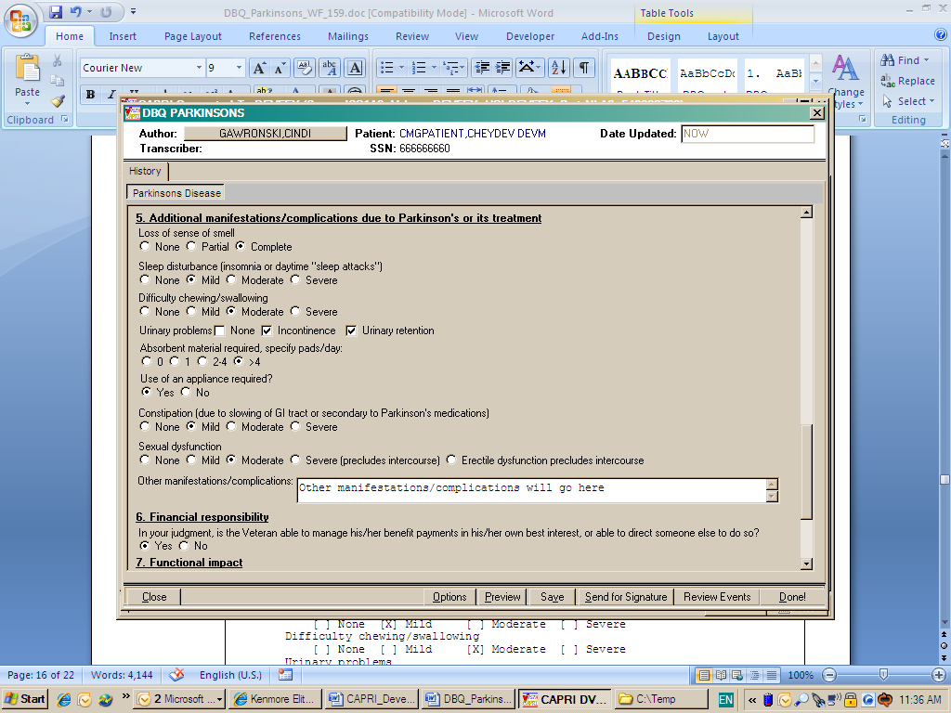

Figure 14: Print Example: DBQ – Parkinson’s Disease – 5. Additional manifestations/complications due to Parkinson’s or its treatment

5. Additional manifestations/complications due to Parkinson's or its treatment
------------------------------------------------------------------------------
Loss of sense of smell
[ ] None [ ] Partial [X] Complete
Sleep disturbance (insomnia or daytime "sleep attacks")
[ ] None [X] Mild [ ] Moderate [ ] Severe
Difficulty chewing/swallowing
[ ] None [ ] Mild [X] Moderate [ ] Severe
Urinary problems
[ ] None [X] Incontinence [X] Urinary retention
Absorbent material required, specify pads/day:
[ ] 0 [ ] 1 [ ] 2-4 [X] >4
Use of an appliance required?
[X] Yes [ ] No
Constipation
(due to slowing of GI tract or secondary to Parkinson's medications)
[ ] None [X] Mild [ ] Moderate [ ] Severe
Sexual dysfunction
[ ] None [ ] Mild [X] Moderate [ ] Severe (precludes intercourse)
[ ] Erectile dysfunction precludes intercourse

Other manifestations/complications: Other manifestations/complications will
go here

Section 6. Financial responsibility
All questions in this section may be answered as described by the rules below. If all mandatory questions are not answered, the error message(s) will appear in a popup window displaying the error message depicted below.

Table 7: Rules: DBQ – Parkinson’s Disease – 6. Financial responsibility
Field/Question | Field Disposition | Valid Values | Format | Error Message
6. Financial Responsibility | Disabled, Read only | N/A | N/A | N/A
In your judgment, is the Veteran able to manage his/her benefit payments in his/her own best interest, or able to direct someone else to do so? | If diagnosis = Yes; Enabled, Mandatory, Choose one valid value  Else; Enabled, Optional | [Yes; No] | N/A | Please answer the question in section 6. Financial responsibility.

Figure 15: Template Example: DBQ – Parkinson’s Disease – 6. Financial responsibility
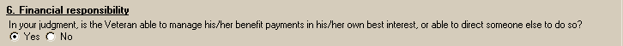
Figure 16: Print Example: DBQ – Parkinson’s Disease – 6. Financial responsibility

6. Financial responsibility

---------------------------

In your judgment, is the Veteran able to manage his/her benefit payments in

his/her own best interest, or able to direct someone else to do so?

[X] Yes [ ] No

Section 7. Functional impact
All questions in this section may be answered as described by the rules below. If all mandatory questions are not answered, the error message(s) will appear in a popup window displaying the error message depicted below.

Table 8: Rules: DBQ – Parkinson’s Disease – 7. Functional impact
Field/Question | Field Disposition | Valid Values | Format | Error  Message
7. Functional Impact | Disabled, Read only | N/A | N/A | N/A
Does the Veteran’s Parkinson’s disease impact his or her ability to work? | If diagnosis = Yes; Enabled, Mandatory, Choose one value  Else; Enabled, Optional | [Yes; No] | N/A | Please provide an answer to the question: Does the Veteran's Parkinson's disease impact his or her ability to work?
If yes, describe impact, providing one or more examples: | If preceding question = Yes; Enabled, Mandatory  Else; Disabled | N/A | Free Text | Please describe the impact of Parkinson's disease on the Veteran's ability to work, providing one or more examples.

Figure 17: Template Example: DBQ – Parkinson’s Disease – 7. Functional impact
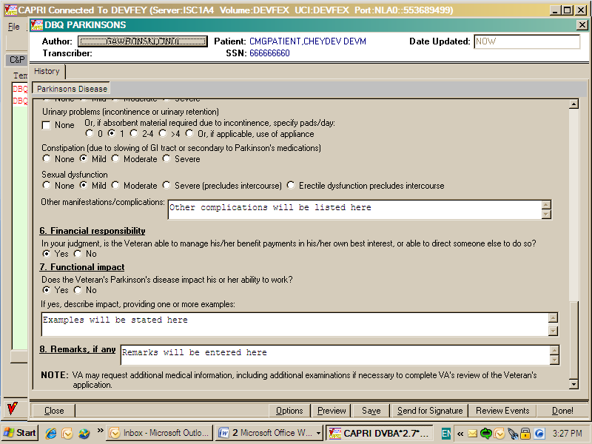
Figure 18: Print Example: DBQ – Parkinson’s Disease – 7. Functional impact

7. Functional impact

--------------------

Does the Veteran's Parkinson's disease impact his or her ability to work?

[X] Yes [ ] No

If yes, describe impact, providing one or more examples: Examples will be

stated here

Section 8. Remarks
All questions in this section may be answered as depicted by the rules below.

Table 9: Rules: DBQ – Parkinson’s Disease – 8. Remarks
Field/Question | Field Disposition | Valid Values | Format | Error  Message
8. Remarks, if any | Disabled, Read only | N/A | N/A | N/A
Remarks | Enabled, Optional | N/A | Free Text | N/A

Figure 19: Template Example: DBQ – Parkinson’s Disease – 8. Remarks

Figure 20: Print Example: DBQ – Parkinson’s Disease – 6. Remarks

8. Remarks, if any

----------------------------

Remarks will be entered here

Parkinson’s Disease AMIE Worksheet
The AMIE worksheets are accessed via the [DVBA C PRINT BLANK C&P WORKSHE] Print Blank C&P Worksheet DBQ PARKINSONS menu option.

Disability Benefits Questionnaire
Parkinson's Disease

Name of patient/Veteran: _______________________ SSN: ________________

Your patient is applying to the U. S. Department of Veterans Affairs
(VA) for disability benefits. VA will consider the information you
provide on this questionnaire as part of their evaluation in processing
the Veteran's claim.

1. Diagnosis

Does the Veteran now have or has he/she ever been diagnosed with
Parkinson's disease? ___Yes ___No

ICD code: _____________________________

Date of diagnosis: ____________________

2. Dominant hand

___Right ___Left ___Ambidextrous

3. Motor manifestations due to Parkinson's or its treatment
(check all that apply)

Stooped posture
___None ___Mild ___Moderate ___Severe

Balance impairment
___None ___Mild ___Moderate ___Severe

Bradykinesia or slowed motion (difficulty initiating movement, "freezing",
short shuffling steps)
___None ___Mild __Moderate ___Severe

Loss of automatic movements (such as blinking, leading to fixed gaze;
typical Parkinson's facies)
___None ___Mild __Moderate ___Severe

Speech changes (monotone, slurring words, soft or rapid speech)
___None ___Mild __Moderate ___Severe

Page: 2

Disability Benefits Questionnaire for
Parkinson's Disease

Tremor (characteristic hand shaking, "pill-rolling")

__Yes __No

Extremities affected:

__ Right upper
___Not affected ___Mild ___Moderate ___Severe

__ Left upper
___Not affected ___Mild ___Moderate ___Severe

__ Right lower
___Not affected ___Mild ___Moderate ___Severe

__ Left lower
___Not affected ___Mild ___Moderate ___Severe

Muscle rigidity and stiffness

__Yes __No

Extremities affected:

__ Right upper
___Not affected ___Mild ___Moderate ___Severe

__ Left upper
___Not affected ___Mild ___Moderate ___Severe

__ Right lower
___Not affected ___Mild ___Moderate ___Severe

__ Left lower
___Not affected ___Mild ___Moderate ___Severe

4. Mental manifestations due to Parkinson's or its treatment

Depression
___None ___Mild __Moderate ___Severe

Cognitive impairment or dementia
___None ___Mild __Moderate ___Severe

Page: 3

Disability Benefits Questionnaire for
Parkinson's Disease

5. Additional manifestations/complications due to Parkinson's or its
treatment

Loss of sense of smell

__None __Partial __Complete

Sleep disturbance (insomnia or daytime "sleep attacks")

___None ___Mild __Moderate ___Severe

Difficulty chewing/swallowing

___None ___Mild __Moderate ___Severe

Urinary problems __None __Incontinence __Urinary retention

Absorbent material required, specify pads/day:

__0 __1 __2-4 __> 4

Use of an appliance required?

__Yes __No

Constipation (due to slowing of GI tract or secondary to Parkinson's
medications)

___None ___Mild __Moderate ___Severe

Sexual dysfunction

___None ___Mild __Moderate ___Severe (precludes intercourse)

__Erectile dysfunction precludes intercourse

Other manifestations/complications:_____________________________________

6. Financial responsibility

In your judgment, is the Veteran able to manage his/her benefit payments
in his/her own best interest, or able to direct someone else to
do so? ___Yes ___No

Page: 4

Disability Benefits Questionnaire for
Parkinson's Disease

7. Functional impact

Does the Veteran's Parkinson's disease impact his or her ability to
work?

___Yes ___No

If yes, describe impact, providing one or more examples:

__________________________________________________________________________

8. Remarks, if any __________________________________________________________

__________________________________________________________________________

Physician signature: _____________________________________ Date: ____________

Physician printed name: __________________________________ Phone: ___________

Medical license #: __________________

Physician address: __________________________________________________________

NOTE: VA may request additional medical information, including additional
examinations if necessary to complete VA's review of the Veteran's application.

